**Project on Comparison of Region based on Sales in Tableau**

Q1) Select Sample Superstore as Dataset

1-Use Sample Superstore Dataset

2-Select Data

3-Use Group by from Data Source Table on a Folder to create a folder to segregate the required data for Customer Name and Order ID inorder to organize the data thoroughly.

Ans) The below attached is the screenshot of the folder which represents the distinct count of order ids for various customer names

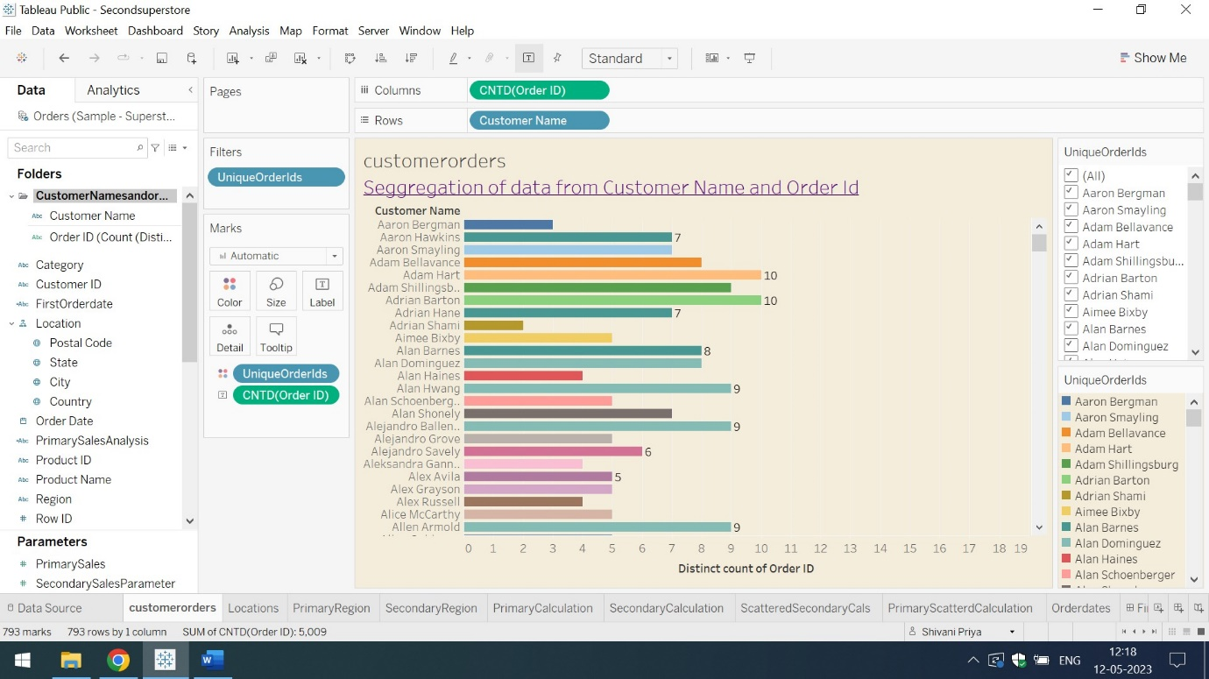

The folder customernameandorderids has two separate entities of Customer Name and distinct order ids.

Q2) Create a hierarchy called Location for the variable Country.

Ans) The screenshot of the location hierarchy for the variable country is shown below:

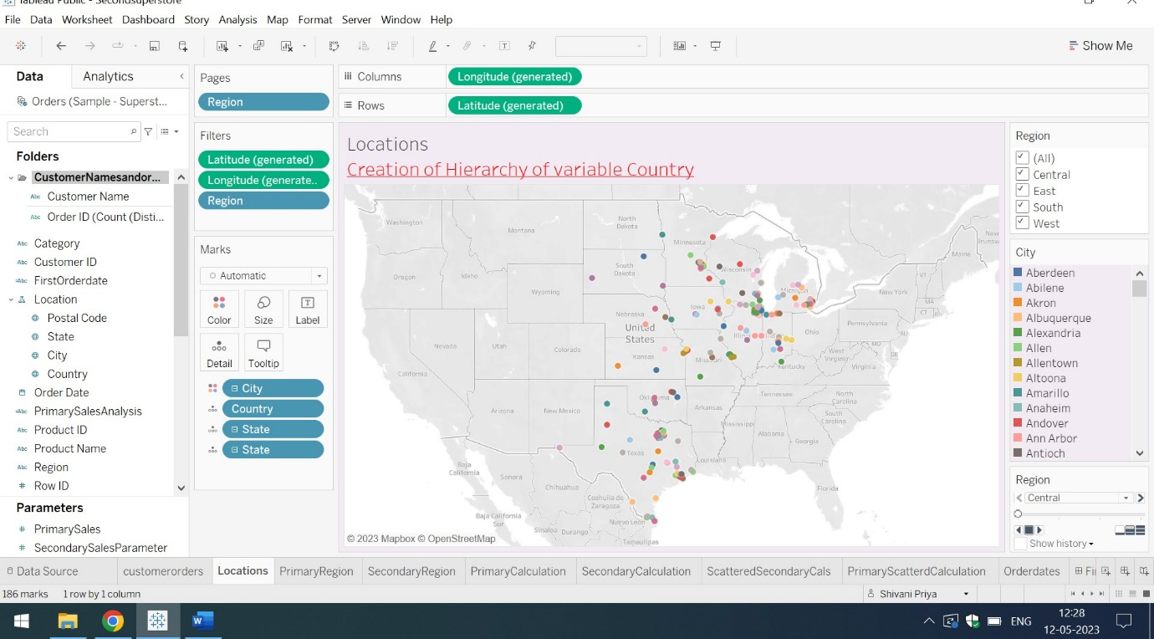

Here in the location hierarchy, the postal code,state and country data has been added

Q3) Create two parameters: Primary Region and Secondary Region with all regions listed in them. Here, primary and secondary region are the two regions where the sales are being compared.

Create Parameters for Primary Region and Secondary Region

Create a Calculated Field for both Primary Region and Secondary Region

Ans) The Parameter of Primary Region Sales are from 1 to 4000 while of Secondary Regions are from 6000 to 8000. These Parameters values are based on assumption and named as Primary Sales and Secondary Sales. If the Primary Sales Values are less than 2000 then the regions are in Loss else in Profit.If the Secondary Sales Values are less than 7000 then the regions are in Loss else in Profit. These are the assumptions of the values from both Primary and Secondary Region. The below attached are the screenshots of Primary and Secondary Regions with calculated fields.

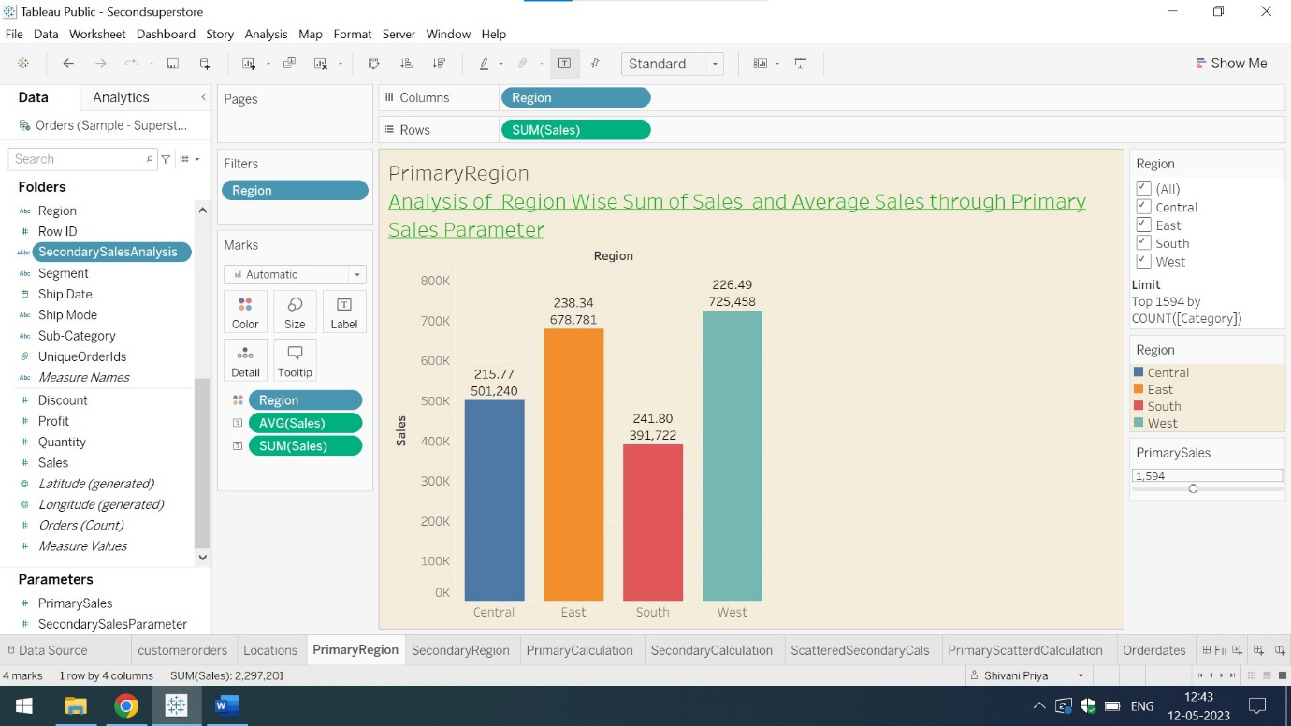

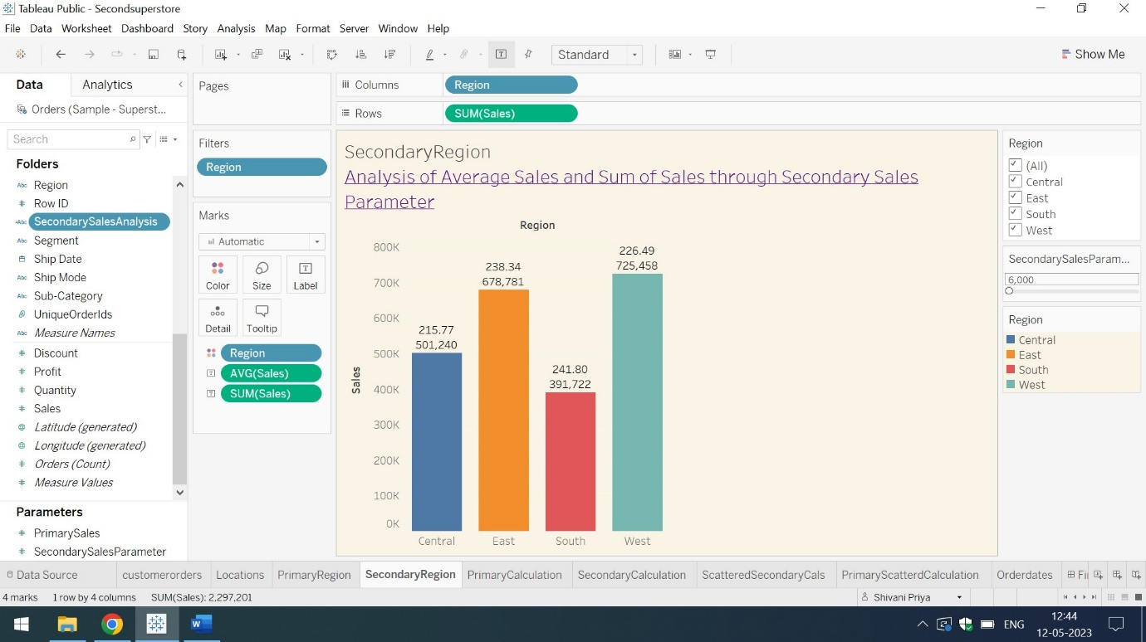

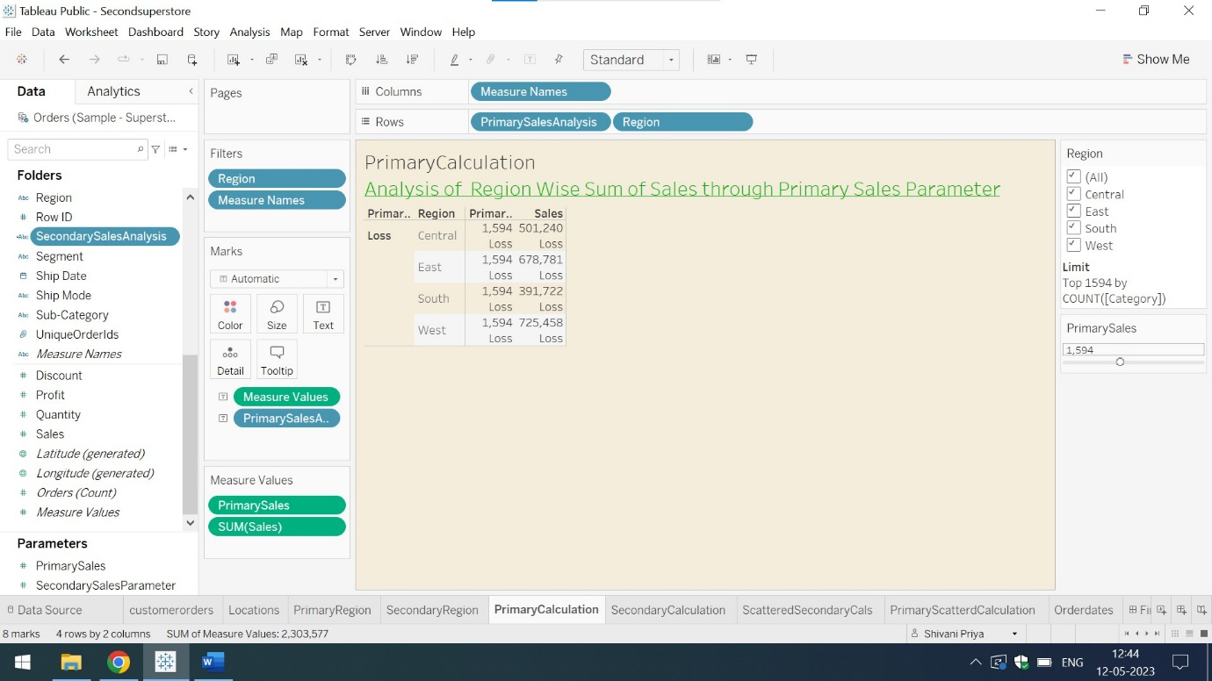

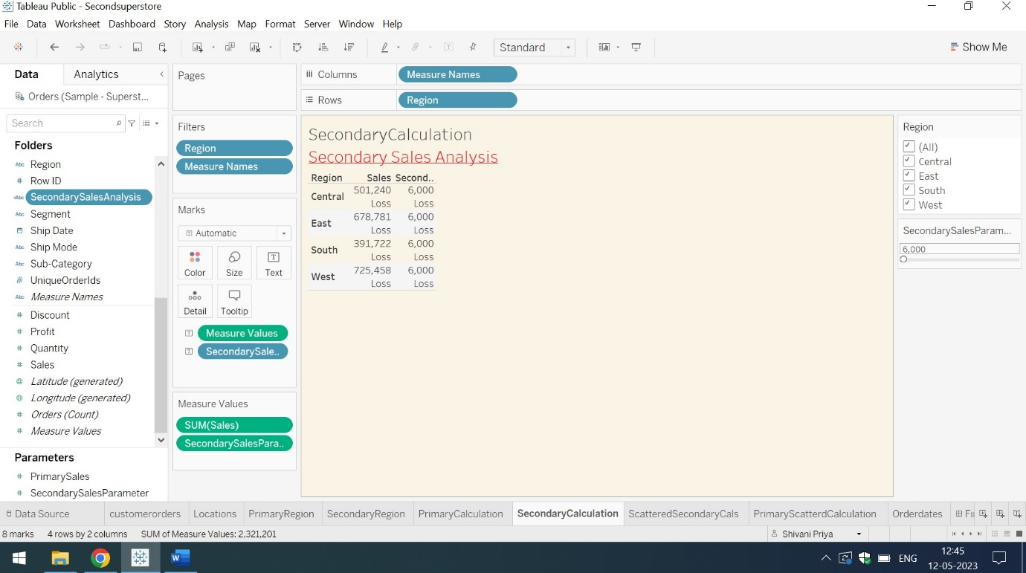

Q4) Create a First Order Date.

Create a Calculated Field and name it as the First Order Date

Ans) The screenshots of the First Order Date of various dates are as follows.Here First Order date is the calculated field which shows the day,months and quarters of various years

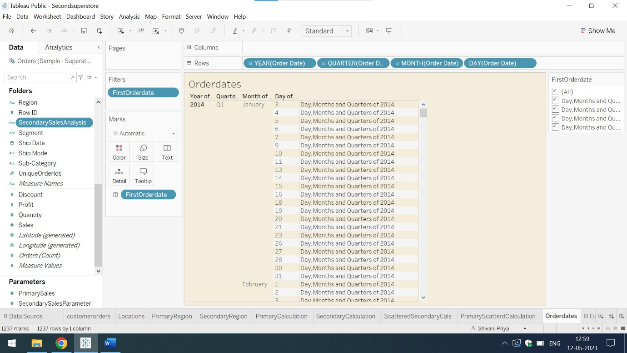

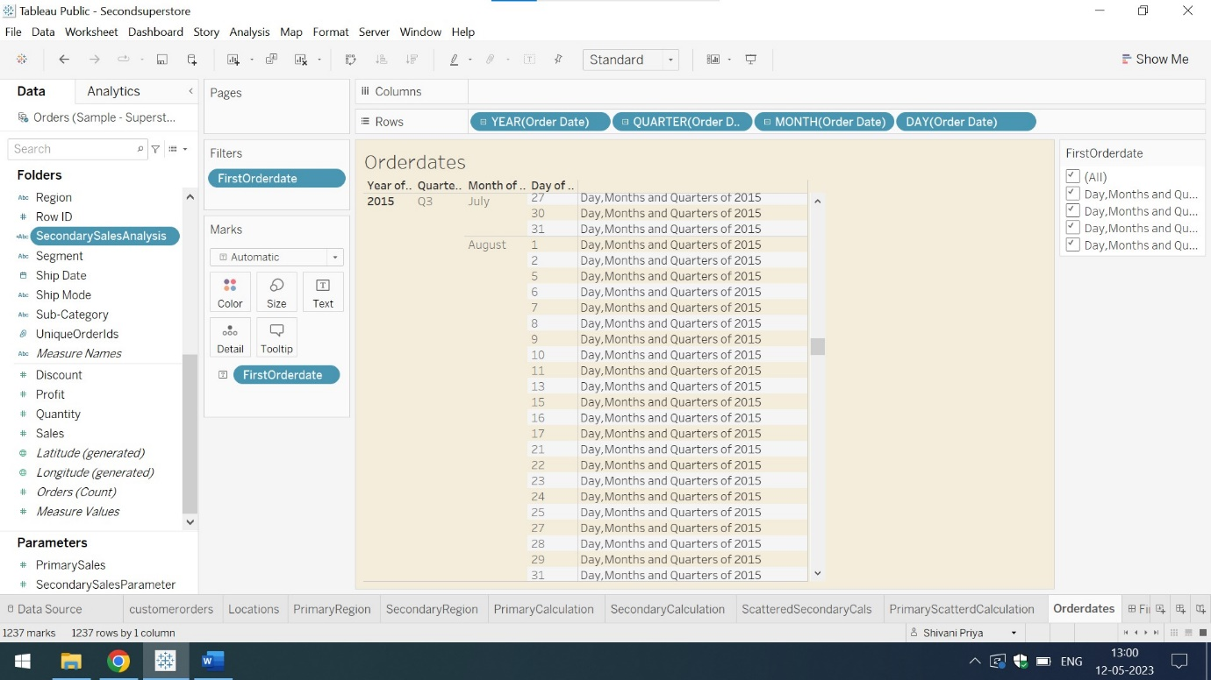

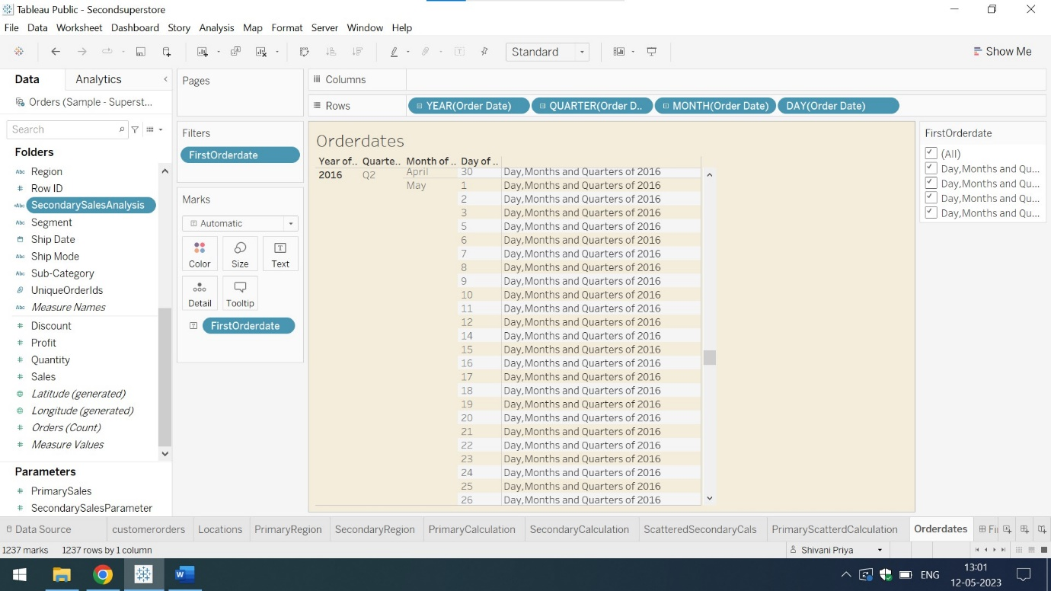

Q5) Create a dashboard.Align all sheets in a dashboard

Ans) The below attached are the screenshots of two dashboards. The first dashboard represents the customerorders and orderdates while the second dashboard represents the location and primary region sales analysis.

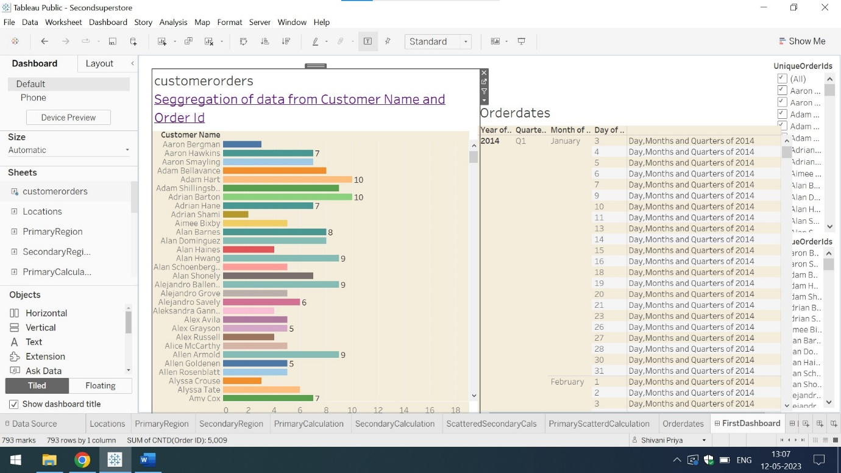

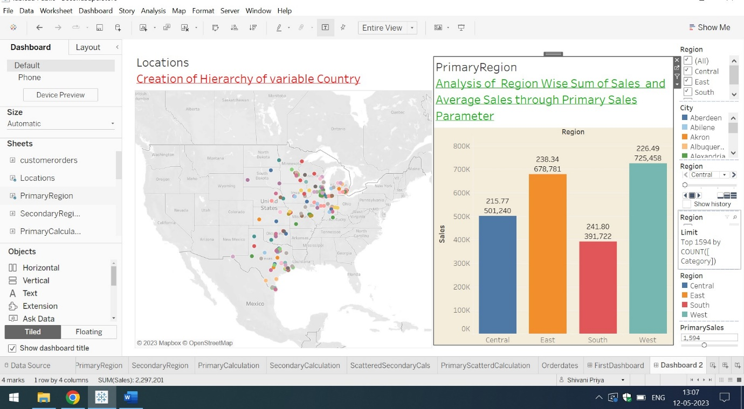

Q6) Partition the dashboard to display the below details of Primary Region and Secondary Region

-First Order Date

-Total Sales

-Average Sales per Order

-No. of Customers

-No. of Orders

-No. of Products in Sale

Ans) The below attached are the screenshots of the dashboards representing the Primary and Secondary Regions are as follows:

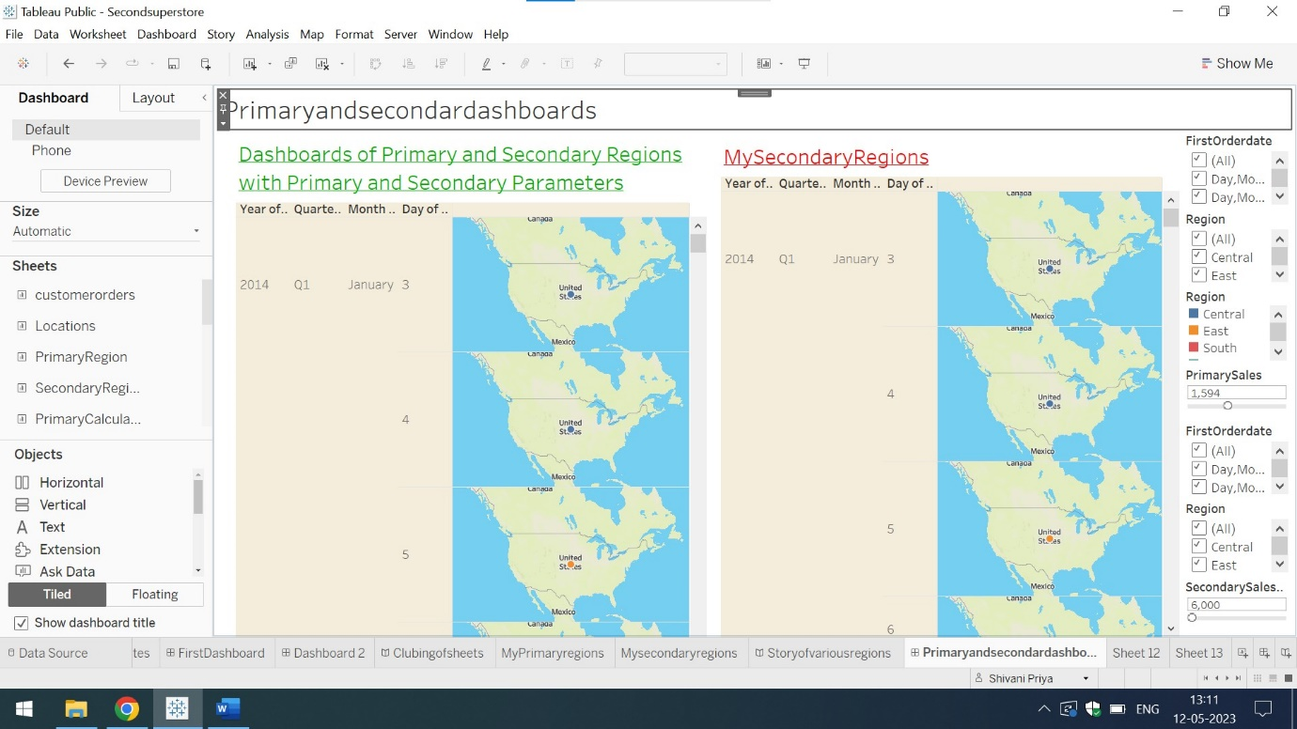

For more detailed description of Comparison of Region based on sales,click on the below mentioned link

<https://public.tableau.com/app/profile/shivani.priya8178/viz/Secondsuperstore/Primaryandsecondardashboards?publish=yes>